Presentation

# Selected Topics CS-2 Projects_Fall2022/2023

Dr. Wessam EL-Behaidy

Team ID : 13

Emotion Recognition Using Convolutional Neural Network (CNN)



Faculty of Computers and Artificial Intelligence

Computer Science Department

2022/2023

***Cover Sheet***

***Team Members :***

|  |  |  |
| --- | --- | --- |
| ID | Name | Grade |
| 202000510 | عبدالرحمن حمدي عبدالعاطي عبدالحميد |  |
| 202000548 | عبد الله شعبان عبد الرازق سيد |  |
| 202000441 | شهاب الدين مختار السعيد عبد الحميد |  |
| 202000171 | آيات ايمن حافظ الشال |  |
| 202000542 | عبد الرحمن ياسر سمير محمد |  |
| 202001109 | يوسف مصطفي محمد عبدالغني |  |

***Emotion Recognition Using Convolutional Neural Network (CNN)***

1. **Introduction**

Facial expression is a valuable expression that portrays human emotion. Emotion expression a natural ability in each human being and people use emotion to communicate their feeling directly. It is also known as a process of non-verbal communication Based on the emotion portrays on a person face, indirectly other people could have a cue on how to communicate with the person. In addition, human emotion recognition is a key technique in human-computer interaction . Emotion is highly dependent on the persons’ body condition and mental state. Hence, it is addressed as the inter-personal communication. Although human can directly express their emotion via facial expression, there exists similar patterns between different facial expressions that contributes to the difficulty in recognizing the emotion correctly . For instance, surprise and fear expression are like one another. Other than that, afraid and surprised expression also exhibits similar expression. Hence, these similarities could lead to the false recognition using the naked eyes . Due to the challenges in recognizing the emotion traditionally, an automatic emotion recognition application highly needed. In the literature, K-Nearest Neighbors is widely used in automatic emotion recognition applied KNN and achieved accuracy more than 85%. However, the implementation of KNN requires high memory and it is slow in performance . On the other hand, the Deep Learning based technique, Convolutional Neural Network (CNN) offers high accuracy performance and fast recognition . CNN has been widely used in automatic emotion recognition such in and obtained promising results with the accuracy obtained more than 90%. Hence, with the great potential of the CNN, this study proposed a mobile-based emotion recognition using Convolutional Neural Network (CNN). The outline of this paper is as follows. section 2 describes on Methodology and followed by section 3 on Results and Analysis. Subsequently, section 4 and section 5 present Conclusion and Acknowledgement, respectively.

1. **Methodology**

This section describes the methodology proposed in this study. This study starts with inputting the real-time images, followed by the implementation of Convolutional Neural Network (CNN) for recognizing the emotion. Succeeding, the recognized emotion will be displayed.

Figure 1 shows the proposed flowchart in this study. Further explanation will be elaborate in the sub section accordingly.

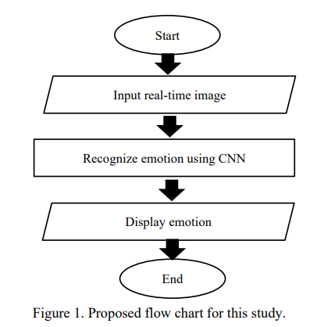

* 1. **Facial Expression Real-Time Images**

This study covers sex types of facial expression which are happy, sad, natural , fear , angry and surprise .

Figure 2 shows example of these sex types of facial expression.

**1. Angry**  **2. fear**  **3. happy** 

**4. natural**  **5. sad** ** 6. Surprise** 

* 1. **Recognize Emotion Using Convolutional Neural Network (CNN)**

Convolutional Neural Network (CNN) is a Deep Learning based technology that has the capabilities to achieve high precision in recognition (Liam Schonevel 2021). CNN has multiple layers where each layer performs a specific transformation function. Convolutional is the first layer to extract features from the input image. The convolutional will then preserves the the relationship between pixels by learning image feature using small squares of input data. Convolution of an image with different filters can perform operations such as edge detection, blur and sharpen by applying filters. ReLu purpose is to introduce non-linearity in ConvNet. The real data would want our ConvNet to learn would be nonnegative linear values. Next, the pooling layer functions’ to reduce the number of parameters when the image is too large. Spatial pooling also called subsampling or down sampling which reduces the dimensionally of each map but retains important information. Spatial pooling can be of different types which is max pooling, average pooling or sum pooling. Full connected layer is flattened the matrix into vector and feed it into a fully connected layer like a neural network.

Figure 3 shows CNN architecture.

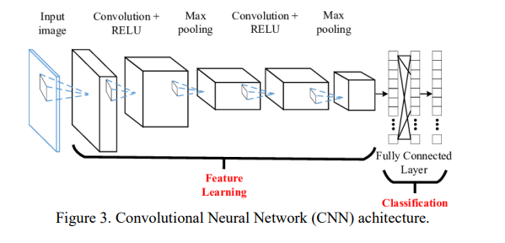

The Deep Learning based technique, Convolutional Neural Network (CNN) is implemented in this study. The MobileNet algorithm is deployed to train the model for recognition. There are four types of facial expressions to be recognized which are happy, sad, surprise, and disgusting. As the result, this study obtained 85% recognition accuracy. In the future, the developed application could be improved by adding more face expression categories.

* ***Our CNN Model***

1. ***Importing the libraries***

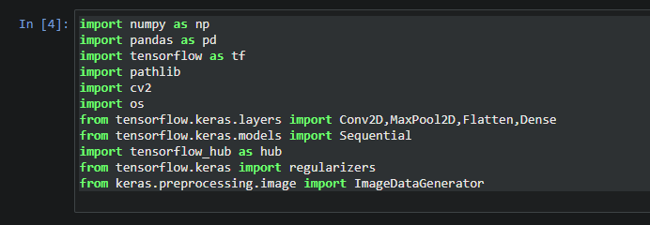

1. ***Importing the Dataset***

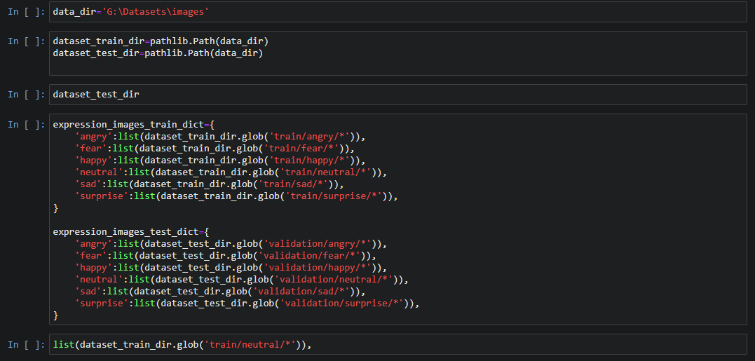

Our Dataset is

“Face expression recognition dataset”

* The total number of samples in dataset is 35500 img.
* The number of samples used in training is 80% of the dataset
* The number of samples used in validation and testing is 30% of the dataset.

You can see our dataset from here

[Face expression recognition dataset | Kaggle](https://www.kaggle.com/datasets/jonathanoheix/face-expression-recognition-dataset)

1. ***Classifying , Scaling and resizing the images then Splitting the dataset***

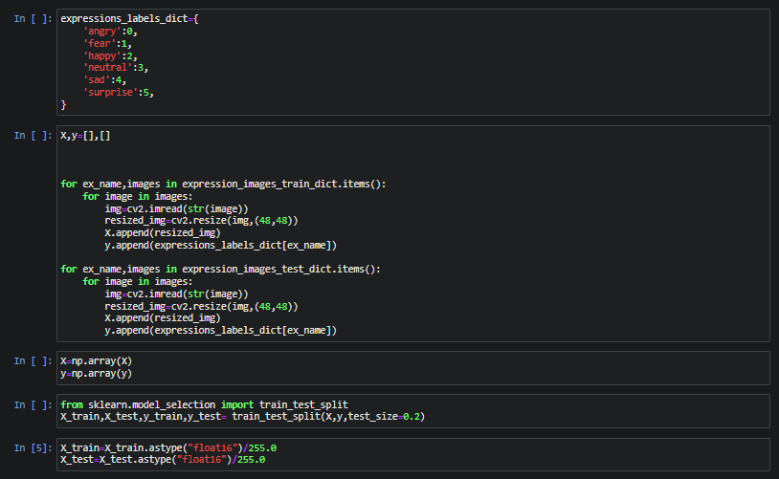

1. **Model Structure**

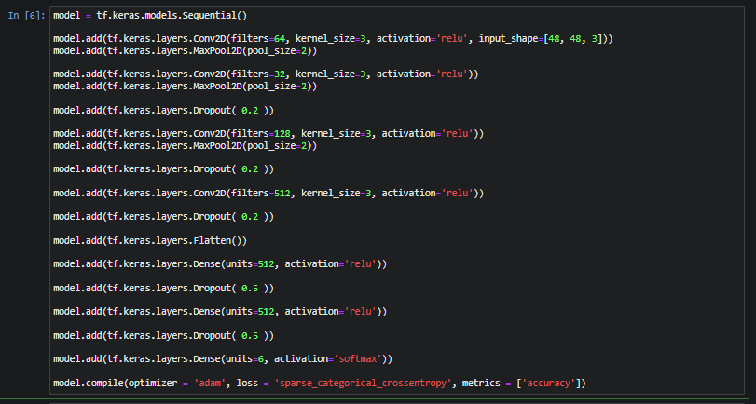

Then the summary of model

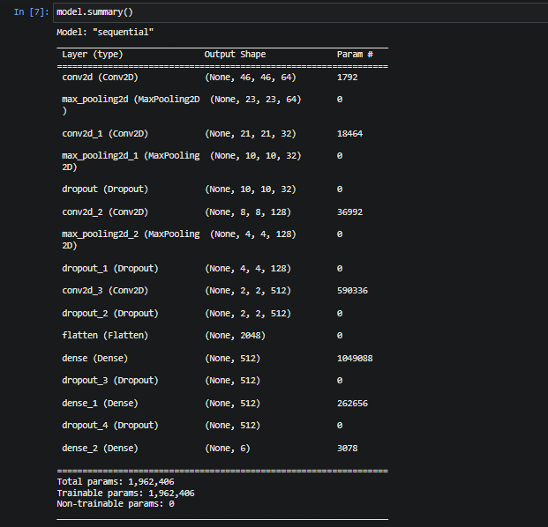

**After we had created the model the we must to fit it**

We fitted our model in 20 epochs



1. **Prediction**

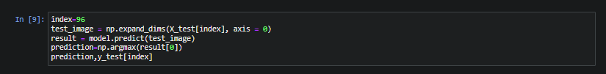

…………………………………………………………………………………

**Charts (plots)**

1. **Confusion matrix**

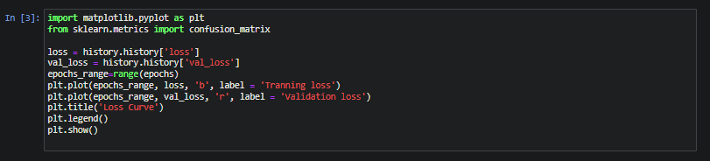

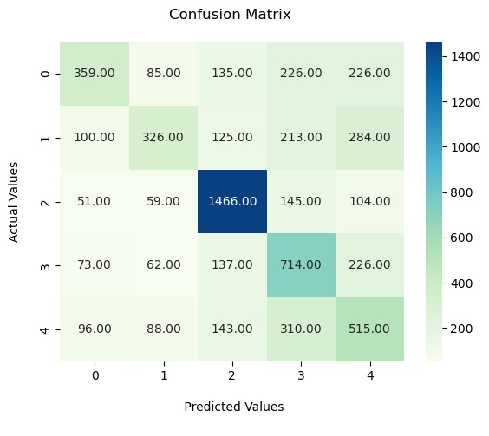

**2- ROC Curve**

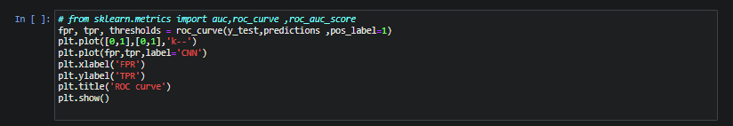

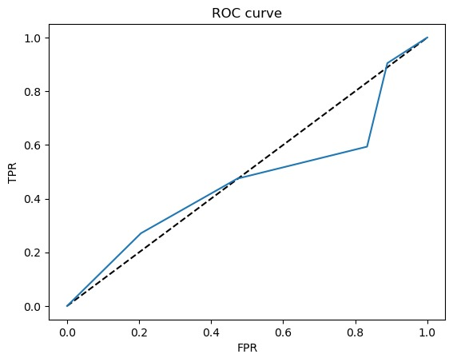

**3- Accuracy Curve**

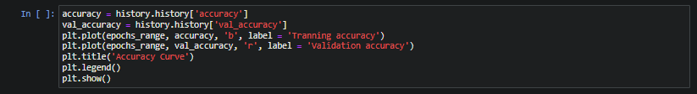

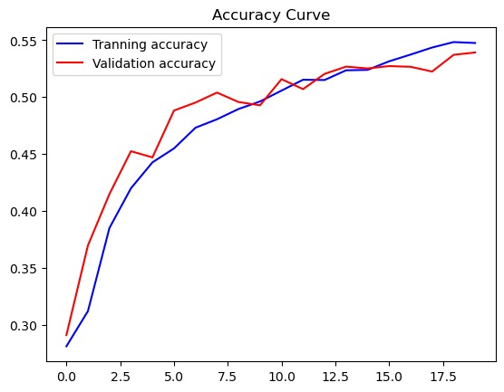

**4- Loss Curve**

